Ideation Phase
Brainstorm & Idea Prioritization Template

Date | 9-07-2026
Team ID | --
Project Name | Shopezz - Full Stack E-Commerce Platform
Maximum Marks | 4 Marks

Brainstorm & Idea Prioritization Template:
Brainstorming provides a free and open environment that encourages everyone within a team to participate in the creative thinking process that leads to problem solving. Prioritizing volume over value, out-of-the-box ideas are welcome and built upon, and all participants are encouraged to collaborate, helping each other develop a rich amount of creative solutions.
Use this template in your own brainstorming sessions so your team can unleash their imagination and start shaping concepts even if you're not sitting in the same room.
Reference: https://www.mural.co/templates/brainstorm-and-idea-prioritization
Step-1: Team Gathering, Collaboration and Select the Problem Statement
Selected Problem Statement:
Traditional online shopping platforms lack an integrated, user-friendly, and scalable solution for customers and administrators. Shopezz aims to provide a modern MERN-based e-commerce platform with secure authentication, product management, cart, wishlist, order tracking, and admin dashboard.
Team Collaboration: Discussed user requirements, competitor analysis, UI/UX expectations, and technical feasibility.
Target Users: Customers, Sellers/Admin, Small Businesses.
Goal: Build a responsive, secure, and scalable shopping application.
Step-2: Brainstorm, Idea Listing and Grouping
Brainstormed Ideas:
• Secure JWT Authentication
• Product Categories & Search
• Wishlist
• Shopping Cart
• Online Checkout
• Order Tracking
• Admin Dashboard
• Product Reviews
• Responsive UI
• Inventory Management
Idea Grouping:
Core Features: Authentication, Products, Cart, Orders
Customer Features: Wishlist, Reviews, Search
Admin Features: Dashboard, User & Product Management
Step-3: Idea Prioritization
Priority (High): Authentication, Product Catalog, Cart, Checkout, Orders
Priority (Medium): Wishlist, Reviews, Search Filters
Priority (Low): Coupons, Recommendations, Analytics

Visual Summary
Step 1
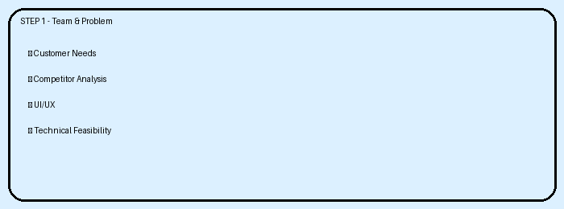
Step 2
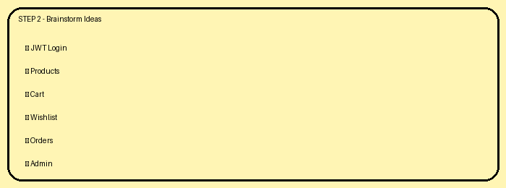
Step 3
